**Python Study Bootcamp**

Prepared by Erdem Çamlıoğlu

secamlioglu@gmail.com

**Week – 1**

1. **IDE Installation**
   1. Get the Github Study Pack
   2. Connect to Jetbrains Account and Github
   3. Install PyCharm Professional IDE
   4. Optional IDE
2. **IDE Installation (Integrated Development Environment)**

We use PyCharm IDE for python coding.

* 1. **Get the Github Study Pack**

Sign in Github in website and take the github study pack. This study pack is [here](https://education.github.com/pack).

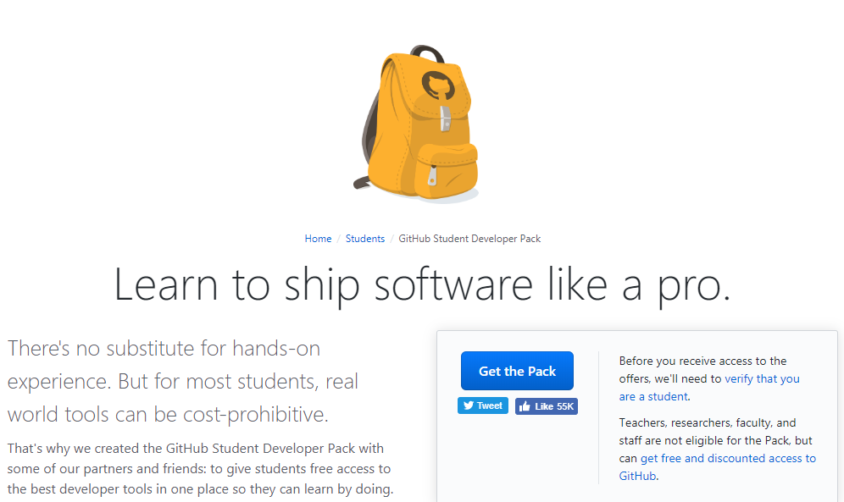Press the “**Get The Pack**” button.

And prove that you are student.

* 1. **Connect to Jetbrains Acc. With Github**

Connect to your Jetbrains account with your Github account.

* Create Jetbrains Account
* Go to account panel
* Connect with Github Account
  1. **PyCharm Installation**

Install PyCharm Professional IDE

* Go back to account page
* Click to “Licenses”
* Get to PyCharm Professional IDE and tap to “Install”
  1. **Optional IDE**

Get the VsCode and install python extension.

* Install VsCode
* Open extensions tab
* Search python extensions (best ext. manufacturer Microsoft)
* Install and restart this editor

and Enjoy the coding ...